Software Requirements Specification (SRS)
Skool-Comm – School-Parent Communication App
Prepared for: Wilgehof Primary School
Course: ITC327W – Software Engineering Project

Group Members
Precious Mchunu | 222078878
Kwanele Mdolo | 223088602
Tsietsi Sebogodi | 223060143
Lesego Mochai | 222046558
Avhasei Rambulana | 221007752
Nothabile Jokazi | 223060076
Itshepeleng Karabo Lerato | 221030790
Lebohang Seekoei | 221045394

Contents
Software Requirements Specification (SRS) 1
1. Project Introduction 4
2. Stakeholder Profile and Current Process 5
2.1 Stakeholder Profile 5
2.2 Current Process 5
Who Participates: 5
What Information is Communicated: 6
2.3 Problems Experienced 7
2.4 How the Problem Affects Users 7
Current Communication Diagram 8
3. Problem Statement 9
Current Problem: 9
Impact: 9
Proposed Solution: 9
4. Project Aim and Objectives 10
4.1 Project Aim 10
4.2 Objectives 10
5. Project Scope 11
6. Stakeholder Needs 12
6.1 Interview Findings 12
6.2 Summary of Stakeholder Needs 13
7. Definitions and Abbreviations 14
8. Stakeholders and User Groups 14
9. Product Perspective 14
10. Main Product Functions 15
11. Functional Requirements 15
12. Non-Functional Requirements 17
13. System Requirements 18
14. Integration Requirements 18
15. Requirements Prioritisation 19
16. Requirements Change Log 21
17. Refined Project Scope 22
17.1 Changes Made 22
17.2 Refined Scope 23
Feasibility Study 24
Introduction 24
Review of Current Project 24
Technical Feasibility 24
Operational Feasibility 25
Economic Feasibility 26
Schedule Feasibility 26
Legal Feasibility 27
Ethical Feasibility 27
Feasibility Summary 28
Overall Feasibility Conclusion 29
Proposed Changes to the Project Scope 32
Appendices 33
Appendix A: Stakeholder Interview Questions 33
Appendix B: Stakeholder Responses 33
Appendix C: Evidence of Stakeholder Engagement 34
Appendix D: Stakeholder Confirmation of Findings 35

1. Project Introduction
Skool-Comm is a digital platform designed to improve communication between Wilgehof Primary School and parents. It will provide a central place where parents can access important school information, academic results, announcements, reminders, attendance information, and school communication.
Wilgehof Primary School is a public, Quintile 5 (fee-paying) primary school located in Wilgehof, Bloemfontein. The school has 900+ learners and 35 educators. The school currently lacks a centralized system for parent communication, presenting a clear opportunity for a digital communication project.
Currently, parents often struggle to stay informed about what is happening at their children's school. Important information such as parent meetings, school events, announcements, and school requirements may be communicated through learners, printed notices, or different messaging platforms. Learners may forget to tell their parents about important information received at school.
Parents also struggle with technology, may lose or change phones, and often receive short notice about school events. The proposed Skool-Comm platform will provide a centralized platform where parents can easily access school information. The school will be able to publish announcements, upcoming meetings, events, and other important notices. Parents will be able to receive information directly instead of relying only on their children to communicate it.
The main stakeholders of the project are school administrators, teachers, and parents or guardians. The system aims to improve school communication, help parents stay informed, reduce unnecessary school visits, and make school-related information easier to access.
Commercial school-communication platforms such as ClassDojo and Remind already exist and offer similar messaging and notification features. However, these are general-purpose products that are not tailored to Wilgehof Primary School's specific context, including its existing manual points system, limited parent technology literacy, and current lack of any centralized digital record-keeping. Skool-Comm is not intended to compete with these commercial platforms, but rather to deliver a purpose-built prototype for this specific stakeholder, using a Flutter, ASP.NET, and Supabase stack that the group can realistically design, build, and test within a single semester.

2. Stakeholder Profile and Current Process

2.1 Stakeholder Profile
ELEMENT DETAILS
ORGANIZATION NAME AND  TYPE | Wilgehof Primary School – Public, Quintile 5 (fee-paying) primary school in Wilgehof, Bloemfontein
STAKEHOLDER'S NAME OR ROLE | Nokulunga Nxusa (Teacher), Paseka Manamela (Teacher)
ORGANIZATION'S MAIN  ACTIVITIES | Providing primary education to learners from Grade R to Grade 7
CONTACT PERSON | Nokulunga Nxusa
CONTACT DETAILS | Phone: 067 168 5856, Email: Nxusanp@ufs.ac.za

2.2 Current Process
The school currently uses a combination of methods to communicate with parents.
Teachers and administrators create information or announcements, which are then
sent through one of several channels including Facebook, WhatsApp, letters, or phone calls. Parents may or may not receive the message. If parents have a response or query, they contact the school through one of these same channels. There is no central tracking system for either the school or the parents.

Who Participates:

PARTICIPANT ROLE
TEACHERS | Send academic updates, behavioural concerns, and communicate with parents via WhatsApp, letters, and phone calls
ADMINISTRATORS | Send school-wide announcements, event information, and urgent notifications via Facebook, letters, and WhatsApp
PARENTS/GUARDIANS | Receive information, raise concerns, and respond to communications
LEARNERS | Deliver physical letters/notices home (often lost or forgotten)

What Information is Communicated:

INFORMATION HOW IT IS COMMUNICATED
TYPE
ACADEMIC | Report cards, test results (via letters or WhatsApp)
Attendance | Attendance is recorded internally but is not consistently communicated to parents.
BEHAVIOURAL | Wilgehof Primary School uses a demerit point system to monitor learner behaviour.  Discipline reports use a demerit point system to monitor learner behaviour: 50 points = detention, 75 points = meeting, and 100 points = parents called in.
SCHOOL EVENTS | Sports days, parent meetings, school closures (letters, WhatsApp, Facebook)
SCHOOL  REQUIREMENTS | Letters, WhatsApp, Facebook
PARENT MEETINGS | Letters, WhatsApp, Facebook
STATEMENTS | Currently paper-based

2.3 Problems Experienced
PROBLEM DESCRIPTION
PARENTS LOSE PHONES | Parents change phones or lose contact numbers
INTERNET CONNECTIVITY | Some parents do not have reliable internet access
WHATSAPP NOT USER-FRIENDLY | Elderly parents struggle to use WhatsApp effectively
SHORT NOTICE MESSAGES | Parents do not always receive enough time to prepare
NO REMINDERS | Parents do not receive reminders about meetings and events
NO YEAR PLAN | Parents would like a year plan to prepare in advance
MANUAL POINTS RECORDING | Behavioural points are recorded manually
PAPER-BASED STATEMENTS | Statements are printed and distributed physically

2.4 How the Problem Affects Users
AFFECTED GROUP IMPACT
TEACHERS | Spend time on manual communication and points recording instead of
 | teaching
PARENTS | Miss important updates; struggle with technology; feel disconnected from the school
ADMINISTRATORS | Overwhelmed by parent queries; cannot track communication effectively
LEARNERS | Inconsistent parental support due to poor communication
SCHOOL  REPUTATION | Parent satisfaction decreases when communication is poor

Current Communication Diagram
Teacher / Admin Parent
│ │
│ 1. Information/ │
│ Announcement │
│ is created │
│ │
▼ │
┌───────────────┐ │
│ Channels │ │
│ • Facebook │─── 2. Sent ──────►│ 3. May or may
│ • WhatsApp │ via │ not receive
│ • Letters │ channel │ the message
│ • Phone │ │
└───────────────┘ │
│ │
│ 4. Response/Query │
│ │
▼ ▼
┌───────────────┐ ┌───────────────┐
│ No Central │ │ No Central │
│ Tracking │ │ Tracking │
│ System │ │ System │
└───────────────┘ └───────────────┘

3. Problem Statement

Current Problem:
Wilgehof Primary School currently uses a combination of Facebook, WhatsApp, letters, and phone calls to communicate with parents. This fragmented approach makes it difficult to ensure that valuable information reaches parents on time.

Impact:
This results in missed messages, no tracking of message delivery, no centralized record of communication, and no reminders or year plan for parents. Teachers and school administrators spend additional time on manual communication and points recording, while parents may miss important updates and struggle with existing communication methods. There is also no reliable record of what information was communicated or received.

Proposed Solution:
An improved solution is needed to centralize school-parent communication. The proposed system will provide reminders, a digital year plan, online statements, and a digital record-keeping system for learners and parents, helping the school communicate information more effectively and giving parents easier access to important school information.

4. Project Aim and Objectives

4.1 Project Aim
To develop an integrated mobile and web prototype that improves communication between Wilgehof Primary School and parents.

4.2 Objectives
OBJECTIVE DESCRIPTION
OBJECTIVE 1 | Allow parents to receive academic, attendance, and event updates
OBJECTIVE 2 | Allow teachers to send announcements and track parent engagement
OBJECTIVE 3 | Allow administrators to manage communication and generate reports
OBJECTIVE 4 | Provide online statements for parents
OBJECTIVE 5 | Provide reminders and a year plan for parents
OBJECTIVE 6 | Create a digital record-keeping system for learners and parents

5. Project Scope
SCOPE ELEMENT GROUP RESPONSE
PROJECT AIM | To develop an integrated mobile and web prototype that improves communication between Wilgehof Primary School and parents.
MAIN OBJECTIVES | Allow parents to receive academic, attendance, and event updates; allow teachers to send announcements and

 | track parent engagement; allow administrators to manage communication and generate reports; provide online statements; provide reminders and a year plan; create a digital record-keeping system for learners and parents.
DELIVERABLES | Flutter mobile app for parents; ASP.NET web dashboard for teachers and administrators; Supabase backend connecting both apps; SRS document; final project presentation.
ACCEPTANCE CRITERIA | Parents can securely log in and view academic progress, attendance, and school events. Parents can view announcements, receive reminders, and access the year plan. Teachers and  administrators can securely access the web dashboard and manage communication. The prototype must run successfully using test data.
EXCLUSIONS | Full integration with the school's existing admin systems; financial/payment systems (except uniform shop link); AI-powered features; SMS or email notifications (in-app only).
CONSTRAINTS | Project must be completed within one semester (15 weeks); must use Flutter, ASP.NET, and Supabase; requires stakeholder availability; no real student data without permission; interface must be simple for elderly parents.
ASSUMPTIONS | Stakeholder will be available for meetings; school will provide feedback; sample/test data can be used; technical resources remain available; parents have access to smartphones.

6. Stakeholder Needs

6.1 Interview Findings
A stakeholder interview was conducted on 21 August 2026 with teachers Nokulunga Nxusa and Paseka Manamela at Wilgehof Primary School. The following findings were recorded:
QUESTION STAKEHOLDER RESPONSE
1. HOW DOES THE SCHOOL CURRENTLY COMMUNICATE WITH PARENTS? | Facebook, WhatsApp groups, letters, phone calls
2. WHAT INFORMATION DO PARENTS REQUEST MOST FREQUENTLY? | Academic results, school events, meeting dates
3. WHAT CHALLENGES HAVE YOU EXPERIENCED WITH THE CURRENT COMMUNICATION METHODS? | Parents lose phones, internet issues, WhatsApp not user-friendly for elderly
4. WHAT COMPLAINTS DO PARENTS COMMONLY HAVE? | Short notice, no reminders, no year plan
5. DO PARENTS STRUGGLE TO ACCESS THEIR CHILDREN'S ACADEMIC RESULTS? | Yes – currently via letters/WhatsApp only
6. HOW ARE SCHOOL EVENTS  COMMUNICATED TO PARENTS? | Letters, WhatsApp, Facebook
7. HOW DO TEACHERS CURRENTLY COMMUNICATE WITH PARENTS? | WhatsApp groups, letters, phone calls
8. WHAT ADMINISTRATIVE TASKS TAKE UP UNNECESSARY TIME? | Manual points recording, printing letters, distributing statements
9. WHAT WOULD MAKE COMMUNICATION BETWEEN THE SCHOOL AND PARENTS EASIER? | Online system, reminders, year plan, online statements
10. IF WE COULD ONLY HELP WITH ONE THING, WHAT WOULD BE MOST VALUABLE? | Record-keeping system for learners and parents

6.2 Summary of Stakeholder Needs
PRIORITY NEED
MUST HAVE | Record-keeping system for learners and parents
COULD HAVE | Online statements for parents
MUST HAVE | Reminders for meetings and events
MUST HAVE | Digital year plan for parents
SHOULD HAVE | Points tracking system
COULD HAVE | Online uniform shop

Definitions and Abbreviations

TERM OR ABBREVIATION MEANING
SRS | Software Requirements Specification
FLUTTER | Framework used to develop the mobile application
ASP.NET | Framework used to develop the web  application
SUPABASE | Shared online backend and database
WIL | Work-Integrated Learning
UI | User Interface
RLS | Row Level Security (Supabase)
POPIA | Protection of Personal Information Act

Stakeholders and User Groups

STAKEHOLDER OR USER ROLE IN THE PROPOSED SYSTEM
WILGEHOF PRIMARY SCHOOL | External stakeholder providing requirements and feedback
PARENTS/GUARDIANS | Mobile application users – receive information and access school updates
TEACHERS | Web application users – send announcements and track engagement
SCHOOL ADMINISTRATORS | Web application users – manage
 | communication and generate reports
LEARNERS | Indirectly affected – benefit from improved parental support

9. Product Perspective

The proposed prototype will include a Flutter mobile application for parents and an ASP.NET web application for teachers and administrators. Both applications will connect to the same Supabase backend and share information in real-time. Teachers and administrators will use the web application to create, update, and delete announcements, while parents will view the published announcements through the mobile application. When a teacher sends an announcement through the web dashboard, it will appear immediately in the mobile app. When a parent views an announcement, the engagement will be tracked and displayed in the web dashboard.

Main Product Functions

COMPONENT MAIN FUNCTIONS
FLUTTER MOBILE APPLICATION | View academic results, view attendance records, view school events and announcements, receive reminders, view online statements, view year plan, update contact information
ASP.NET WEB APPLICATION | Create, update, and delete announcements; track parent engagement; manage communication and generate reports; manage parent contact details; record learner points; view communication history.
SUPABASE BACKEND | Store user profiles (parents, teachers,
 | administrators), store communication records and announcements, store academic and attendance data, enable real-time synchronisation, provide secure authentication and access control

Functional Requirements

ID REQUIREMENT PRIORITY
FR1 | Parents must be able to view academic progress (report cards, test results) | Must Have
FR2 | Parents must be able to view attendance records | Must Have
FR3 | Teachers and  administrators can create, update, and delete announcements, while parents can view them. | Must Have
FR4 | Parents must be able to view online statements | Could Have
FR5 | Parents must receive reminders for meetings and events | Must Have
FR6 | Parents must be able to view the year plan | Must Have
FR7 | Teachers must be able to track parent engagement  (viewed/read) | Should Have
FR8 | Administrators must be able to manage communication and generate reports | Must Have
FR9 | Teachers must be able to record and track learner | Should Have
 | points
FR10 | The system must securely store all announcements and communication records in Supabase | Must Have
FR11 | The system must store learner and parent/guardian information, including learner details, contact information, academic progress, attendance and communication records. Access must be limited to authorized users. | Must Have
FR12 | Parents must be able to update their contact information | Must Have
FR13 | Administrators must manage users (create, update, delete accounts) | Must Have
FR14 | The system should provide parents with a link to the school's uniform/stationery supplier | Could Have

Non-Functional Requirements

ID REQUIREMENT PRIORITY
NFR1 | Only authorized parents may view their child's information | Must Have
NFR2 | Only authorized teachers and administrators may send announcements | Must Have
NFR3 | Error messages must be clear and understandable | Must Have
NFR4 | The mobile interface must display correctly on Android smartphones | Must Have
NFR5 | The prototype must use test data (no real student data without permission) | Must Have
NFR6 | The system must be easy to use for parents with basic smartphone skills | Must Have
NFR7 | The interface must be simple enough for elderly parents | Must Have

System Requirements

ID REQUIREMENT PRIORITY
SR1 | The mobile application must be developed using  Flutter | Must Have
SR2 | The web application must be developed using  ASP.NET | Must Have
SR3 | The shared backend must use Supabase | Must Have
SR4 | The source code must be stored in GitHub | Must Have
SR5 | The project must be completed within one semester (15 weeks) | Must Have

14. Integration Requirements
ID REQUIREMENT PRIORITY
IR1 | Information entered through Flutter must be stored in Supabase | Must Have
IR2 | Records stored in Supabase must be available to the ASP.NET application | Must Have
IR3 | Updates made through ASP.NET must be reflected in Flutter where applicable | Must Have
IR4 | Announcements sent through ASP.NET must appear in the Flutter app | Must Have
IR5 | Authentication data must be shared between Flutter and ASP.NET using  Supabase Authentication. | Must Have

Requirements Prioritisation

ID REQUIREMENT TYPE PRIORITY RELATED
STAKEHOLDER
NEED
FR1 | Parents must view academic progress | Functional | Must Have | Parents request  academic  results
FR2 | Parents must view attendance records | Functional | Must Have | Record-keeping system needed
FR3 | Teachers and administrators can create, update, and delete announcements, while parents can view them. | Functional | Must Have | Parents miss events due to poor communication
FR4 | Parents must view online statements | Functional | Could Have | Statements are currently paper based
FR5 | Parents must receive reminders | Functional | Must Have | Short notice is  a common  complaint
FR6 | Parents must view the year plan | Functional | Must Have | Parents want to prepare in advance
FR7 | Teachers must  track  engagement | Functional | Should Have | No way to  confirm if parents received messages
FR8 | Administrators must manage communication | Functional | Must Have | Overwhelmed by parent queries
FR9 | Teachers must record points | Functional | Should Have | Points are recorded manually
FR10 | Store | Functional | Must Have | No record of

 | communication records in Supabase |  |  | what was sent or received
FR11 | Provide a record-keeping system | Functional | Must Have | Stakeholder's top priority
FR12 | Parents must update contact information | Functional | Must Have | Parents lose phones and change numbers
FR13 | School administrators need controlled user accounts | Functional | Must Have | Staff accounts need to be  controlled
FR14 | The system should provide parents with a link to the school's uniform/stationery supplier. | Functional | Could have | Parents currently must visit the school office to get uniform pricing information
NFR1 | Only authorized parents view child's info | Non-functional | Must Have | Protect learner information
NFR2 | Only authorized staff send announcements | Non-functional | Must Have | Control who communicates with parents
NFR3 | Error messages must be clear | Non-functional | Must Have | Parents may struggle with technology
NFR4 | Mobile interface must work on  Android | Non-functional | Must Have | Most parents use Android phones
NFR5 | Prototype must use test data | Non-functional | Must Have | No real student data without permission
NFR6 | System must be easy to use | Non-functional | Must Have | Parents have basic smartphone  skills
NFR7 | Interface must  be simple for elderly | Non-functional | Must Have | Elderly parents struggle with  WhatsApp
SR1 | Mobile app must use Flutter | System | Must Have | Course requirement
SR2 | Web app must use ASP.NET | System | Must Have | Course requirement
SR3 | Backend must use Supabase | System | Must Have | Course requirement
SR4 | Source code | System | Must Have | Course
 | must be in GitHub |  |  | requirement
SR5 | Project must be completed in one semester | System | Must Have | Course timeline
IR1 | Flutter information stored in Supabase | Integration | Must Have | System components must share data
IR2 | Supabase records available to ASP.NET | Integration | Must Have | Staff need to see parent reports
IR3 | ASP.NET updates reflected in Flutter | Integration | Must Have | Parents need to see staff updates
IR4 | Announcements from ASP.NET appear in Flutter | Integration | Must Have | Parents need to  receive announcements
IR5 | Flutter & ASP.NET | Authentication | Must Have | Secure access for all users

Requirements Change Log
DATE CHANGE REASON
27 AUGUST 2026 | Online statements changed from "Must Have" to "Could Have" | We do not have  permission yet to tap into the school database
27 AUGUST 2026 | Points tracking system changed from "Must Have" to "Should Have" | It’s one of the requirements the stakeholder asked for
27 AUGUST 2026 | Academic progress requirement (FR1) added | Was accidentally omitted from initial requirements list
27 AUGUST 2026 | Online uniform shop confirmed as "Could Have" | identified as a potential feature during stakeholder engagement and deprioritised to Could-Have; will be developed only if time permits after Must-Have and Should-Have features are complete.

Refined Project Scope

17.1 Changes Made
CHANGE DESCRIPTION
SIMPLIFY THE INTERFACE | The system must be designed for elderly parents who struggle with technology.  This is now a key design constraint.
PRIORITISE FEATURES | Must-Have features (communication, academic progress, attendance, announcements, reminders, year plan, and record-keeping) will be developed first. Should-Have features, such as points tracking and parent engagement tracking, will be added if time permits. Could-Have features, such as online statements and the uniform shop link, will only be added if time permits.
ALLOCATE TIME FOR LEARNING | The group will spend the first week of Phase 3 learning Supabase integration and real-time synchronization.
USE TEST DATA ONLY | No real student data will be used without permission.
DOCUMENT LIMITATIONS | Any incomplete features will be documented as known limitations in the final submission.

17.2 Refined Scope

SCOPE ELEMENT DETAILS
IN SCOPE | Flutter mobile app for parents to view academic progress, attendance, events, announcements, reminders, and the year plan; ASP.NET web dashboard for teachers and administrators to manage communication, engagement, reports, and learner records; Supabase backend connecting both applications with real-time synchronization and role-based access control.
OUT OF SCOPE | Online statements (Could Have — postponed for prototype; may be added if time permits).
This refined scope ensures the project can be completed within the available semester while delivering a meaningful prototype that addresses the stakeholder's core needs.

Feasibility Study

Introduction
This feasibility study evaluates whether the Skool-Comm project can be successfully completed within the available time, resources, and skills. The study considers six areas: technical, operational, economic, schedule, legal, and ethical feasibility. Each area is assessed based on the stakeholder's needs, the group's capabilities, and the project constraints.

Review of Current Project
The main problem being addressed is that Wilgehof Primary School currently uses fragmented communication methods including Facebook, WhatsApp, letters, and phone calls. This results in missed messages, no tracking of delivery, no centralized record of communication, and no reminders or year plan for parents. The problem affects teachers, parents, and school administrators because teachers spend time on manual communication and points recording, parents miss important updates and struggle with technology, and there is no accountability for what was communicated or received.
The proposed solution is a digital platform called Skool-Comm, which includes a Flutter mobile application for parents and an ASP.NET web application for teachers and administrators. Both applications will connect to a shared Supabase backend.The mobile application will allow parents to view academic results, attendance records, school events, announcements, reminders, and the year plan. Online statements are considered a Could-Have feature and will only be developed if time permits.
The web application will allow teachers to send announcements, track parent engagement, manage communication, generate reports, manage parent contact details, and record learner points. Supabase will manage user profiles, communication records, announcements, and academic and attendance data.
The functions that appear most difficult include real-time synchronization between Flutter and ASP-NET, tracking parent engagement (viewed/read), and online statements. The functions that require skills the group still needs to develop include Supabase integration, real-time synchronization, and push notifications. The functions that may require more time than is available include the points tracking system, online uniform shop, and full reporting suite.

Technical Feasibility
The group has foundational skills in Flutter and ASP.NET from previous coursework. Members are familiar with the basic concepts of mobile and web development and have experience working with version control systems. The group can work with Supabase, as it is a beginner-friendly platform with extensive documentation and we also did it in first semester. Flutter and ASP.NET can both connect to the same Supabase backend using official SDKs and REST APIs, making integration technically possible.
All group members have suitable development computers, and Android smartphones are available for testing. Reliable internet access is available through campus Wi-Fi and personal data.
However, some technical skills still need to be learned. The group needs to develop proficiency in Supabase Row Level Security (RLS) policies, Flutter state management, and API integration. The most technically challenging functions include real-time engagement tracking, which requires Supabase Real-time, and push notifications, which require integration with Firebase Cloud Messaging.
Based on the assessment, the project is considered feasible with changes. The group has the foundational skills required for Flutter and ASP.NET development. The main technical challenge is Supabase integration and real-time synchronization, which can be learned using online tutorials and documentation. The prototype will focus on core functions and avoid advanced features that require more expertise than the group currently possesses.

Operational Feasibility
The prototype directly addresses the stakeholder's problem by centralizing communication and providing tracking and accountability features that are currently missing. The mobile application will be used by parents and guardians of learners at Wilgehof Primary School, while the web application will be used by teachers and school administrators. Most parents have access to smartphones, and the school can confirm this. However, some parents struggle with internet access and WhatsApp, which is a recognised risk.
The proposed solution will fit the organization's current activities by complementing existing communication methods. However, users will require guidance and training, especially elderly parents who struggle with technology. The interface must be designed to be simple enough for elderly parents, and this is a key design requirement.
Based on the assessment, the project is considered feasible with changes. The solution addresses the stakeholder's problem directly, but the system must be designed with simplicity in mind for elderly parents. Some parents with limited internet access may need alternative communication options, but the app will be designed to work on basic smartphones.

Economic Feasibility
All group members have access to internet access and data, either through campus Wi-Fi or personal mobile data. Transport to the stakeholder is available, and the group will travel together for safety. All group members have suitable development computers, and Android smartphones are available for testing. The required software includes Flutter, ASP.NET , and Supabase, all of which are freely available. The Supabase free tier is sufficient for the prototype, and presentation resources are available on campus.
No additional budget is required for this project, as all tools and resources are either freely available or already owned by group members.
Based on the assessment, the project is considered feasible. The project requires only free development tools and personal equipment that group members already own. No additional budget is required, and the free tiers of all services are sufficient for the prototype.

Schedule Feasibility
The Microsoft Project schedule allocates time for system design, development, integration, testing, and corrections across Phases 2 and 3. Development activities include Flutter, ASP.NET, and Supabase integration, followed by system testing, bug corrections, and stakeholder evaluation. The schedule provides sufficient time for the core features, but some additional features may need to be postponed if development takes longer than expected.
This timeline is adequate for the core features of the system. Supabase integration is planned throughout the development phase, and stakeholder feedback sessions are included at key milestones.
However, some features may be ambitious for the available time. The online statements, online uniform shop, and advanced reporting functions may require more time than is available. The group has therefore prioritized Must-Have features such as academic progress, attendance, announcements, reminders, the year plan, and record-keeping. Should-Have and Could-Have features will only be added if time permits.
Based on the assessment, the project is considered feasible with changes. The core communication features can be completed within the semester, but some features like online statements and the uniform shop may need to be postponed or simplified. The group will prioritize Must-Have functions first and add additional features only if time permits.

Legal Feasibility
The prototype will collect personal information, including parents' contact details and learners' academic information. However, all information collected is necessary for the prototype's functionality. Access to information will be restricted to authorized users only: parents will only be able to view their own child's information, while teachers and administrators will have appropriate access levels.
Test data will be used during development, and no real student data will be used without permission. Passwords and private keys will be protected using environment variables and will never be stored in source code or uploaded to GitHub. No confidential stakeholder information will be included in the prototype.
Based on the assessment, the project is considered feasible. The project will use only test data during development and will not store real student or parent information without permission. Passwords and API keys will be stored in environment variables and never uploaded to GitHub. The project complies with POPIA guidelines through the use of test data and role-based access control.

Ethical Feasibility
The stakeholder fully understands the purpose of the project and agreed to participate after being informed of the project's scope and objectives. The project does not collect unnecessary personal information, and all information collected is essential for the prototype's functionality. The proposed solution will not negatively affect intended users; instead, it is designed to help parents and staff by improving communication and accountability.
Information will be used only for its intended purpose of school-parent communication. The proposed prototype accurately reflects stakeholder needs, as requirements were gathered directly from the stakeholder during the interview process. All users will be treated fairly and responsibly, with the system being designed to be inclusive for elderly parents who struggle with technology.
Based on the assessment, the project is considered feasible. The stakeholder was fully informed of the project's purpose and agreed to participate. The project does not collect unnecessary personal information and will treat all users fairly and responsibly. The prototype is designed to address legitimate stakeholder needs.

Feasibility Summary
FEASIBILITY DECISION MAIN REASON CHANGE
AREA REQUIRED
TECHNICAL | Feasible with changes | Foundational skills exist;  Supabase integration needs learning | Allocate time for learning and training
OPERATIONAL | Feasible with changes | Addresses the problem; interface must be simple for elderly parents | Simplify interface design
ECONOMIC | Feasible | Free tools and existing equipment are sufficient | None required
SCHEDULE | Feasible with changes | Core features achievable; some features may need postponement | Prioritise MustHave features
LEGAL | Feasible | Test data only; credentials kept secure | None required
ETHICAL | Feasible | Stakeholder informed; fair treatment of users | None required

Overall Feasibility Conclusion
The proposed Skool-Comm project is feasible with changes.
The group has access to the required development tools (Flutter,ASP.NET , Supabase,
GitHub) and has foundational skills in each technology. The stakeholder is willing to participate and provide feedback. The core communication functions can be completed within the semester timeline.
However, several changes are required to ensure successful completion. The interface must be simplified for elderly parents who struggle with technology. Features must be prioritized, with Must-Have features developed first and Could-Have features added only if time permits. The group must allocate time for learning Supabase integration and real-time synchronization. Only test data will be used, and no real student data will be used without permission. Any incomplete features will be documented as known limitations.
The main strengths of the project are its direct alignment with stakeholder needs, the availability of free development tools, and the group's foundational skills in the required technologies. The main limitations are the need for additional learning in Supabase integration and the risk of schedule delays due to ambitious features.
To ensure that the project can be completed within the semester, the group will priorities Must-Have features first, postpone or simplify Could-Have features, allocate time for learning, and maintain close communication with the stakeholder throughout the development process.

Project Risk Register

The Project Risk Register identifies potential risks that may affect the successful completion of the Skool-Comm project. The risks were identified based on the project's scope, technology, schedule, stakeholder involvement and available resources. Each risk is assessed according to its likelihood and impact, with mitigation and contingency actions assigned to an appropriate project role.
The Risk Manager, Lebohang Seekoei, is responsible for compiling, maintaining and reviewing the Project Risk Register, while individual risks are assigned to the team member best positioned to monitor and implement the appropriate mitigation and contingency actions.

Proposed Changes to the Project Scope
Based on the feasibility analysis, the following changes are proposed:
- Simplify the interface – The system must be designed for elderly parents who struggle with technology. This will be a key design constraint.
- Prioritize features – Must-Have features (academic progress, attendance, announcements, reminders, year plan, and record-keeping) will be developed first. Should-Have features such as points tracking and parent engagement tracking will be added if time permits. Could-Have features such as online statements and the uniform shop link will only be added if time permits.
- Allocate time for learning – The group will spend the first week of Phase 3 learning Supabase integration and real-time synchronization.
- Use test data only – No real student data will be used without permission.
- Document limitations – Any incomplete features will be documented as known limitations in the final submission.

Appendices

Appendix A: Stakeholder Interview Questions

How does the school currently communicate with parents?
What information do parents request most frequently?
What challenges have you experienced with the current communication methods?
What complaints do parents commonly have?
Do parents struggle to access their children's academic results?
How are school events communicated to parents?
How do teachers currently communicate with parents?
What administrative tasks take up unnecessary time for teachers or administrators?
What would make communication between the school and parents easier?
If we could only help with one thing, what would be most valuable?

Appendix B: Stakeholder Responses

QUESTION STAKEHOLDER RESPONSE

1. HOW DOES THE SCHOOL CURRENTLY COMMUNICATE WITH PARENTS? | FACEBOOK, WHATSAPP GROUPS, LETTERS, PHONE CALLS
2. WHAT INFORMATION DO PARENTS REQUEST MOST FREQUENTLY? | Academic results, school events, meeting dates
3. WHAT CHALLENGES HAVE YOU EXPERIENCED WITH THE CURRENT COMMUNICATION METHODS? | Parents lose phones, internet issues, WhatsApp not user-friendly for elderly
4. WHAT COMPLAINTS DO PARENTS COMMONLY HAVE? | Short notice, no reminders, no year plan
5. DO PARENTS STRUGGLE TO ACCESS THEIR CHILDREN'S ACADEMIC RESULTS? | Yes – currently via letters/WhatsApp only
6. HOW ARE SCHOOL EVENTS  COMMUNICATED TO PARENTS? | Letters, WhatsApp, Facebook
7. HOW DO TEACHERS CURRENTLY COMMUNICATE WITH PARENTS? | WhatsApp groups, letters, phone calls
8. WHAT ADMINISTRATIVE TASKS TAKE UP UNNECESSARY TIME? | Manual points recording, printing letters, distributing statements
9. WHAT WOULD MAKE COMMUNICATION BETWEEN THE SCHOOL AND PARENTS EASIER? | Online system, reminders, year plan, online statements
10. IF WE COULD ONLY HELP WITH ONE THING, WHAT WOULD BE MOST VALUABLE? | Record-keeping system for learners and parents

Appendix C: Evidence of Stakeholder Engagement

ELEMENT DETAILS
MEETING DATE | 21 August 2026
MEETING LOCATION | Wilgehof Primary School
ATTENDEES | Itshepeleng, Avhasei, Lesego, Precious, Nothabile, Tsika, Kwanele, Lebo
STAKEHOLDERS | Nokulunga Nxusa and Paseka Manamela
PURPOSE | To understand current communication methods and identify stakeholder needs
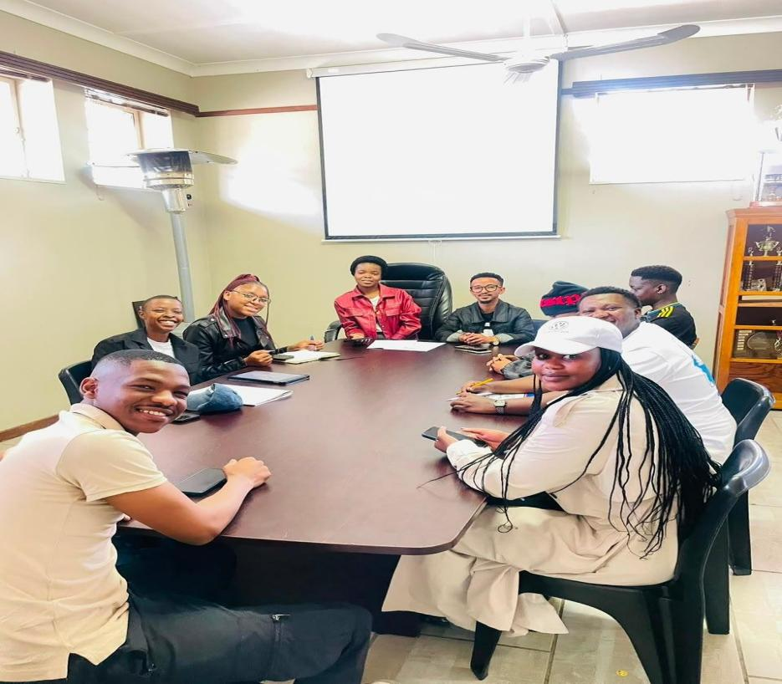

Appendix D: Stakeholder Confirmation of Findings
THE STAKEHOLDER CONFIRMED THAT THE MAIN FINDINGS WERE ACCURATE, INCLUDING:
CURRENT COMMUNICATION METHODS (FACEBOOK, WHATSAPP, LETTERS, PHONE CALLS)
KEY CHALLENGES (LOST PHONES, INTERNET ISSUES, ELDERLY PARENTS STRUGGLING WITH WHATSAPP)
PRIORITY NEEDS (RECORD-KEEPING SYSTEM, ONLINE STATEMENTS, REMINDERS, YEAR
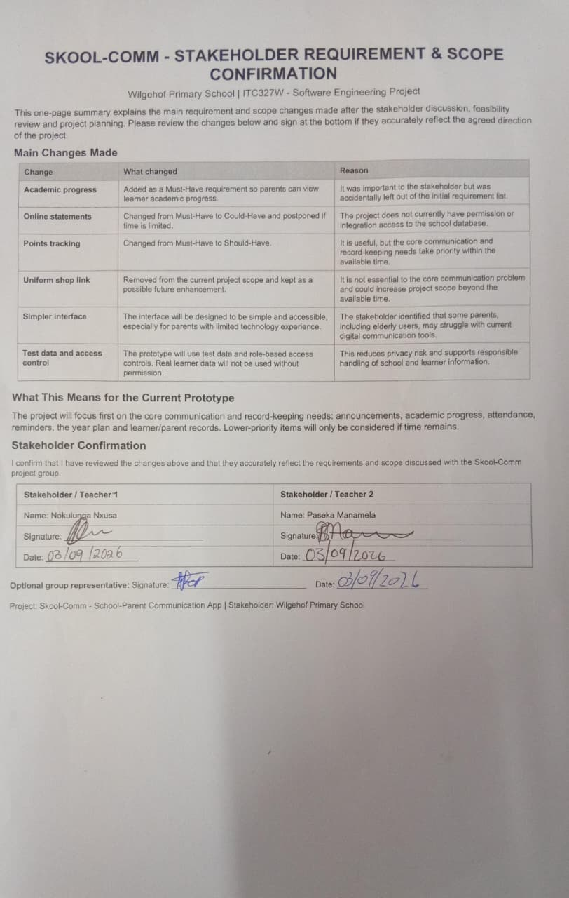

(PLAN)
